1. Problem Description:

Write a Python program that asks the user for their age and prints a message based on the age. Ensure that the program handles cases where the input is not a valid integer.

Input Format:

A single line input representing the user's age.

Output Format:

Print a message based on the age or an error if the input is invalid.

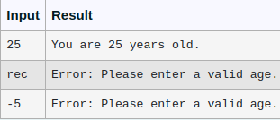

def main():

try:

Age = input()

age = int(Age)

if age >= 0:

print("You are {} years old.".format(age))

else:

print("Error: Please enter a valid age.")

except ValueError:

print("Error: Please enter a valid age.")

except EOFError:

print("Error: Please enter a valid age.")

main()

2. Develop a Python program that safely performs division between two numbers provided by the user. Handle exceptions like division by zero and non-numeric inputs.

**Input Format:** Two lines of input, each containing a number.

**Output Format:** Print the result of the division or an error message if an exception occurs.

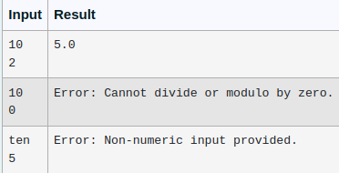

try:

num1 = float(input())

num2 = float(input())

print(num1 / num2)

except ZeroDivisionError:

print('Error: Cannot divide or modulo by zero.')

except ValueError:

print("Error: Non-numeric input provided.")

3. Write a Python program that asks the user for their age and prints a message based on the age. Ensure that the program handles cases where the input is not a valid integer.

**Input Format:** A single line input representing the user's age.

**Output Format:** Print a message based on the age or an error if the input is invalid.

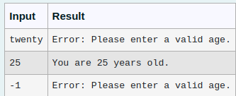

def main():

try:

Age = input()

age = int(Age)

if age >= 0:

print("You are {} years old.".format(age))

else:

print("Error: Please enter a valid age.")

except ValueError:

print("Error: Please enter a valid age.")

except EOFError:

print("Error: Please enter a valid age.")

main()

4. Write a Python program that performs division and modulo operations on two numbers provided by the user. Handle division by zero and non-numeric inputs.

Input Format:

Two lines of input, each containing a number.

Output Format:

Print the result of division and modulo operation, or an error message if an exception occurs.

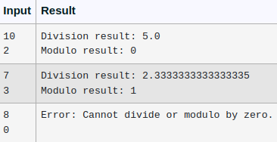

def division_modulo():

try:

numerator = int(input(""))

denominator = int(input(""))

if denominator == 0:

raise ZeroDivisionError("Cannot divide or modulo by zero.")

print(f"Division result: {numerator / denominator}")

print(f"Modulo result: {numerator % denominator}")

except ZeroDivisionError as zde:

print(f"Error: {str(zde)}")

except ValueError:

print("Error: Non-numeric input provided.")

except Exception as e:

print(f"Error: {str(e)}")

division_modulo()

5. Problem Description:

Write a Python script that asks the user to enter a number within a specified range (e.g., 1 to 100). Handle exceptions for invalid inputs and out-of-range numbers.

Input Format:

User inputs a number.

Output Format:

Confirm the input or print an error message if it's invalid or out of range.

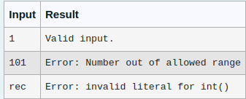

def main():

n = input()

try:

num = int(n)

if 1<= num <=100:

print("Valid input.")

else:

print("Error: Number out of allowed range")

except ValueError:

print("Error: invalid literal for int()")

main()